Geeks for geeks:
keywords : https://www.geeksforgeeks.org/list-of-all-java-keywords/
** The keywords const and goto are reserved, even they are not currently in use.
- const -Reserved for future use
- goto – Reserved for future use
Object Oriented Programming (OOPs) Concept in Java

Polymorphism: override
Private, final, static(method hiding) method cannot be overridden,
We cannot override constructor as parent and child class can never have constructor with same name

https://www.geeksforgeeks.org/object-oriented-programming-oops-concept-in-java/ continue….

String: String is a sequence of characters. In java, objects of String are immutable which means a constant and cannot be changed once created.
Creating a String
There are two ways to create string in Java:
- String literal
String s = “GeeksforGeeks”;
- Using new keyword
String s = new String (“GeeksforGeeks”);

- StringBuffer: StringBuffer is a peer class of String that provides much of the functionality of strings. String represents fixed-length, immutable character sequences while StringBuffer represents growable and writable character sequences.
Syntax:
StringBuffer s = new StringBuffer("GeeksforGeeks");
- StringBuilder: The StringBuilder in Java represents a mutable sequence of characters. Since the String Class in Java creates and immutable sequence of characters, the StringBuilder class provides an alternate to String Class, as it creates a mutable sequence of characters.
Syntax:
StringBuilder str = new StringBuilder();

Arrays in Java
- Every array type implements the interfaces Cloneable and java.io.Serializable.
- Marker interface (cloneable, serializable)
Deep, Shallow and Lazy Copy

Jagged Array:
A jagged array is an array of arrays such that member arrays can be of different sizes, i.e., we can create a 2-D array but with a variable number of columns in each row. These types of arrays are also known as Jagged arrays

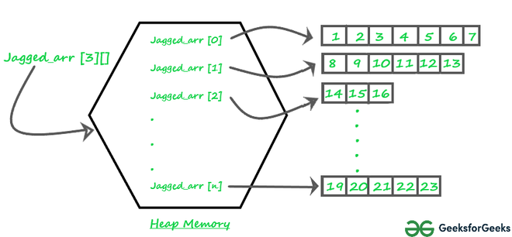

Example:
Syntax: data_type array_name[][] = new data_type[n][]; //n: no. of rows
array_name[] = new data_type[n1] //n1= no. of colmuns in row-1
array_name[] = new data_type[n2] //n2= no. of colmuns in row-2
array_name[] = new data_type[n3] //n3= no. of colmuns in row-3
.
.
.
array_name[] = new data_type[nk] //nk=no. of colmuns in row-n
Alternative, ways to Initialize a Jagged array :
int arr_name[][] = new int[][] {
new int[] {10, 20, 30 ,40};
new int[] {50, 60, 70, 80, 90, 100};
new int[] {110, 120};
};

OR

int[][] arr_name = {
new int[] {10, 20, 30 ,40};
new int[] {50, 60, 70, 80, 90, 100};
new int[] {110, 120};
};
Arrays class in Java

static int binarySearch(elementToBeSearched): These methods searches for the specified element in the array with the help of Binary Search algorithm.
Ex: Arrays.binarySearch(intArr, keyToBeSearched));
Syntax: binarySearch(T[] a, int fromIndex, int toIndex, T key, Comparator<T> c)
copyOf(originalArray, newLength)
Arrays.toString(Arrays.copyOf(intArr, 10))

copyOfRange(originalArray, fromIndex, endIndex)
Arrays.toString(Arrays.copyOfRange(intArr, 1, 3))
static boolean deepEquals(Object[] a1, Object[] a2)
Arrays.deepEquals(intArr, intArr1)

fill(originalArray, fillValue)
// Get the Arrays
int intArr[] = { 10, 20, 15, 22, 35 };
int intKey = 22;
Arrays.fill(intArr, intKey);
Integer Array on filling: [22, 22, 22, 22, 22]

mismatch(array1, array2): This method finds and returns the index of the first unmatched element between the two specified arrays

